**Social Development**

Second stage of MyEcho – Questions Stage

**DISABILITY**

Definition: *Persons with disabilities include those who have long-term physical, mental, intellectual or sensory impairments which in interaction with various barriers may hinder their full and effective participation in society on an equal basis with others.*

It is now quite common to be asked on an application form if you define yourself as a disabled person (The Equality Act 2010 and the United Nations (UN) Convention on [disability rights](https://www.un.org/development/desa/disabilities/convention-on-the-rights-of-persons-with-disabilities/convention-on-the-rights-of-persons-with-disabilities-2.html)).

As previous parameters, this will be rated between 0 and 1.

The more disabled, the closest to one, BUT the candidate should still be able to:

* Carry out a task that is an essential part of the work
* Take part in an interview
* Decide if the interviewers need to make reasonable adjustments for you in a selection process

(From the government website GOV.uk)

Note: Ali mentioned about getting access to NHS data ?

**FAMILIAL STABILITY**

(Might be worth renaming as Environment)

Based on the deprivation rankings excel spreadsheet:

$$0≤\frac{\sum{criteria ranking}}{Highest ranking*number of criteria}≤1$$

As an example for the time being, we can detail the above formula as:

$$0≤\frac{em+cr+lc}{326*3})≤1$$

With:

**em** is employment deprivation in the area

**cr** is crime rate deprivation in the area

**lc** is the living environment in the area

Note: the 326 is the highest possible ranking (the least deprived) and we multiply by 3 because of 3 criteria

**GEOGRAPHICAL LOCATION**

Looking at the address, cross-reference it with Zoopla area guide to get the current average value of the area:

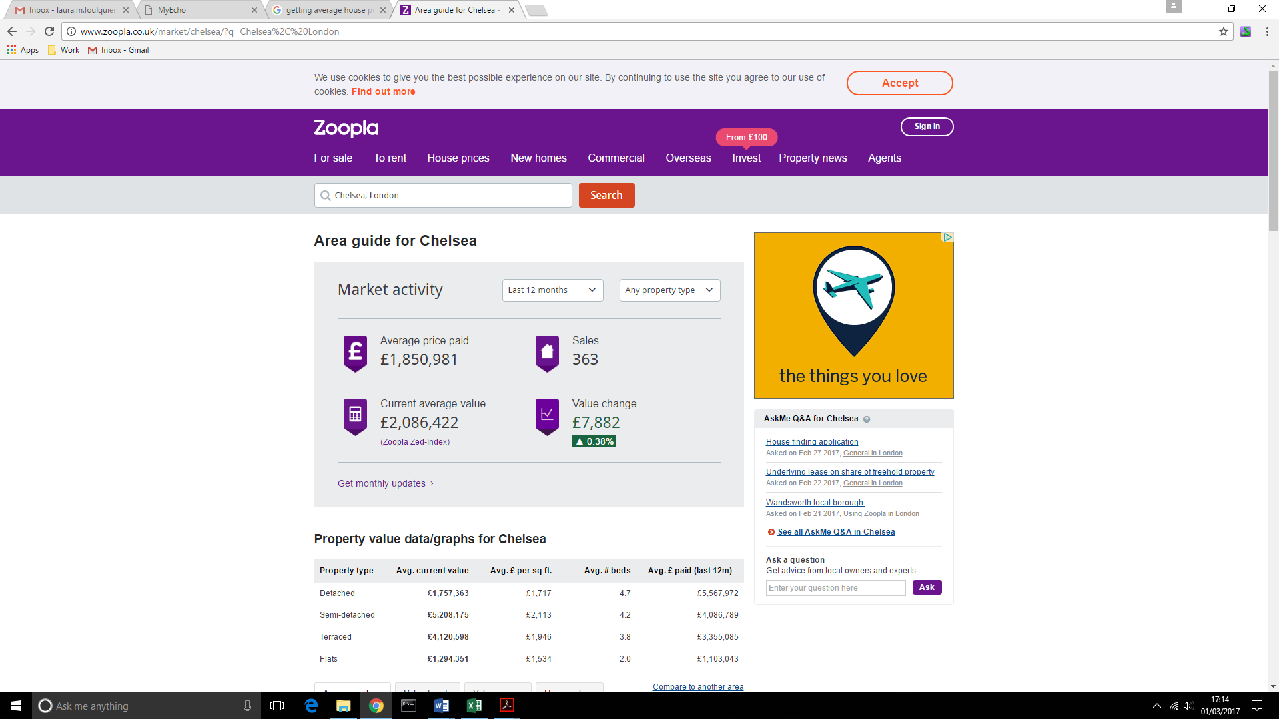

Theory

From Zoopla: use the list of district codes to get the current average value of property in the area. The list of district codes can be found:

<https://en.wikipedia.org/wiki/List_of_postcode_districts_in_the_United_Kingdom>

You can use the url from Zoopla and just change the url code with the district code(in bold):

http://www.zoopla.co.uk/house-prices/browse/ **DDA/**

The normalised equation to be used would then be:

$$0≤1-\frac{value-min}{max-min}≤1$$

With **value** being the current average value of the district,

**Max** and **min** being the maximum average value in the UK and the minimum respectively.

Think to consider:

The years spent at actual house and previous addresses (and the actual average price at this time)

Found some information on <http://landregistry.data.gov.uk/app/ukhpi/explore>.

Unfortunately, the most granular level of information is “local authorities” (ie: Southwark, Greenwich …), and the oldest records start in January 1995.

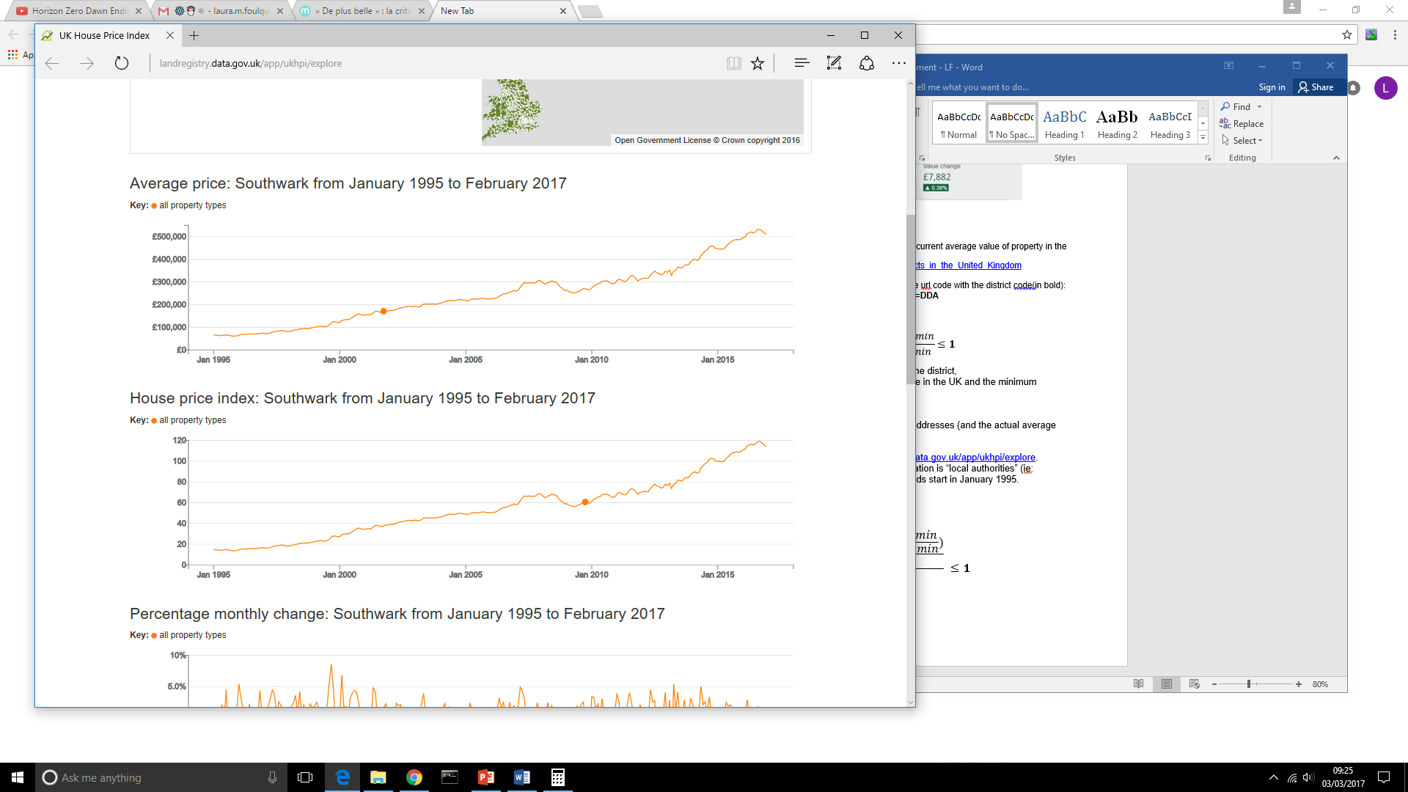

The equation could then be updated as follow:

$$0≤ 1-(\frac{\sum_{i=0}^{n}{\frac{\left(\frac{{val}_{i}-min}{max-min}\right)}{y_{i}}}}{\sum_{i=0}^{n}{y_{i}}}) ≤1$$

With **i** the number of years lived in specific area,

**vali** the average value of the area during these years

**SOCIAL CLASS**

Questions:

* *Who attended university in your family?* (Options: Mother, Father, Both Parents)
* *What is your parent’s job?* (Drop-down list: Unemployed, Officials and Managers, Professionals, Technicians, Sales Workers, Craft Workers, Operatives, Laborers, Service Workers

(see description here: <https://www.cityofmadison.com/dcr/documents/EEO-1JobCat.pdf>)

From the answer, we could estimate the parent’s income (roughly)

Check if the school the candidate went to had free meals:

(Data have been saved in social development folder)

<https://www.gov.uk/government/publications/universal-infant-free-school-meals-uifsm-funding-allocations-2016-to-2017>